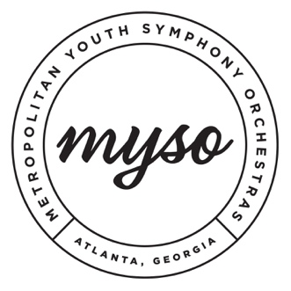
Concert Dates:

Concert #1:​ November 3, 2019 at Kopleff Recital Hall
Concert #2:​ February 16, 2020 at Rialto Center for the Arts
Concert #3:​ May 10, 2020 at Rialto Center for the Arts

All concerts will begin at 3:00pm. Call times will be announced the week prior.

Rehearsal Dates:

**Symphony rehearses in room 405 and Philharmonia rehearses in room 430 in the Aderhold Learning Center**

*Symphony Rehearsal: 3pm - 5:30pm**Philharmonia Rehearsal: 3pm - 5:30pm*

September 1: No Rehearsal – Labor Day
September 8: Rehearsal 1-1
September 15: Rehearsal 1-2
September 22: Rehearsal 1-3
September 29: Rehearsal 1-4

October 6: Rehearsal 1-5
October 13: No Rehearsal – Fall Break
October 20: Rehearsal 1-6
October 27: Rehearsal 1-7

November 3: CONCERT # 1@ Kopleff Recital Hall
November 10: No Rehearsal
November 17: Rehearsal 2-1
November 24: No Rehearsal – Thanksgiving

December 1: Rehearsal 2-2
December 8: Rehearsal 2-3
December 15: Rehearsal 2-4
December 22: No Rehearsal – Winter Break
December 29: No Rehearsal – Winter Break

January 5: Rehearsal 2-5
January 12: Rehearsal 2-6
January 19: No Rehearsal – MLK
January 26: Rehearsal 2-7

February 2: Rehearsal 2-8
February 9:​ ​Rehearsal 2-9
February 16: CONCERT #2 @ Rialto Center for the Arts February 23: No Rehearsal

March 1: Rehearsal 3-1
March 8: Rehearsal 3-2
March 15: Rehearsal 3-3
March 22: Rehearsal 3-4
March 29: No Rehearsal – Spring Break

April 5: Rehearsal 3-5
April 12: No Rehearsal – Easter April 19: Rehearsal 3-6
April 26: Rehearsal 3-7

May 3: Rehearsal 3-8
May 10: CONCERT #3 @ Rialto Center for the Arts

Symphony Sectional Dates:
September 15
October 20
January 12
February 2
March 15
April 26

Other Important 2019-2020 Dates:
May 11 (Saturday): Auditions
May 18 (Saturday): Auditions
May 24 (Friday): Placement results released

June 1(Saturday): Commitments and tuition deposits due

August 18 (Sunday): Auditions to fill vacant positions
August 21: (Wednesday): Final audition results released
August 23: (Friday): Final MYSO commitments and deposits due
August 25 (Sunday): Student & Parent Meeting and music folder pick up

September 30: Tuition Due

Concerto & Scholarship Competitions
January 5: Concerto & Scholarship Competition Applications Due
January 26: Concerto & Scholarship Competition Auditions
February Concert: Concerto Competition Winner Announced
May Concert: Scholarship Competition Winners Announced

2020-2021 Audition Dates
May 9 (Saturday)
May 16 (Saturday)
August 16 (to fill vacant positions)

